Directory Attender ®
Version 1.0x

White Paper



Directory Attender is a member of the Attender Utilities family

Copyright
Under the copyright laws, neither the documentation nor the software can be copied, photocopied, reproduced, translated, or reduced to any electronic medium of machine-readable form, in whole or in part, without the written consent of SHERPA SOFTWARE GROUP, INC.
Copyright 2002 Sherpa Software Group, Inc.
All rights reserved. Printed in the United States.
Directory Attender is a registered trademark, and Attender Utilities is a trademark of Sherpa Software Group, Inc.
Lotus and Lotus Notes are registered trademarks, and LotusScript is a trademark, of the Lotus Development Corporation.

1. Introduction 1-1
2. Benefits 2-1
Reduce your exposure 2-1
Return on investment 2-1
3. Product summary 3-1
Release information/schedule 3-1
User demographics 3-1
Supported versions 3-1
Supported platforms 3-1
Server impact 3-2
4. Product features 4-1
Document management 4-1
Group document management 4-2
Person document management 4-4
Server document management 4-6
Other document management 4-10
Content management 4-11
ACL management 4-12
Directory requests 4-13
Other features 4-14
5. Summary 5-1
6. Contact information 6-1

Introduction
Directory Attender is a Lotus Notes Administration product that manages Lotus Notes directories (Name and Address Books). The management is carried out automatically by Directory Attender’s enforcement of Directory Restrictions created by Lotus Notes administrators. These Directory Restrictions can manage directories in one of these three ways: Access Control List, Contents and Documents.
Infrastructure implications are a problem to companies of any size. The Lotus Notes directories are the ‘brain’ of the Lotus Notes infrastructure. Documents within these databases allow mail routing, server replication and user authentication (in addition to many other required processes), to occur. If the contents of the directories are comprised, not only are there infrastructure issues, but also potentially damaging security issues. This is not an acceptable situation. Typically, all directory modifications should occur on one server per domain. However, sometimes administrators either forget to organize their changes, or administrators can make changes that are not supposed to occur. Either way, the result is that one or more server processes could be adversely affected. In addition, communication is sometimes an issue among administrators, especially when distributed administration is active. This lack of communication can easily lead to confusion and inadvertent modifications to the directories. Also factoring in as a need, is the redundancy of the directory management. For instance, if a change is required for more than one server document, the administrator must update each document individually. Obviously, the more changes that are performed, the greater risk that an error was made. Directory Attender can not only keep track of what has occurred within your directories, but also ensure that specified documents will be consistent in their values.

Benefits

Reduce your exposure
Directory Attender can help the administrators identify current problems, but can also help prevent problems from occurring. Both scenarios can save your company money, either due to decreased time needed by the administrators to manage the directories, or by helping to reduce possible security issues, that could cause havoc within your infrastructure. There is nothing more frustrating for an administrator than to have ‘cleaned up’ the directories, only to find his/her changes usurped by the latest administrator working within the directory. Imagine the exposure to your company if your email quit routing to either servers or people! Needless to say, this could be very damaging due to people not receiving information that is critical in making business decisions.
By enforcing ACL, content and document restrictions, the administrators can move their focus to other problems that require their intervention.

Return on investment
There are three types of return on investment for Directory Attender:
- The reduction in the amount of time spent by the administrators managing the directories. Administrators typically are attempting to correct issues that either someone else or something else has caused. Having this process automated, will not only save the administrators time, but will also help prevent repetitive issues.
- The decreased risk of documents within directories being altered, without the administrators knowledge. Within administration, it usually requires much more time to identify an issue, than it takes to resolve it.
- The reduction of risk regarding security issues within the Lotus Notes infrastructure. There are not too many issues within a company that will get an administrator’s attention more quickly, than problems involving security.

Product summary
Directory Attender was created to alleviate the administrators from manually managing the directories or to help administrators identify potential problems prior to the issues being public knowledge and to provide a facility to automate the changes that are required.

Release information/schedule
This is the first release of Directory Attender. This initial version of the product contains requested features from potential customers as well as functionality that we felt would be useful. An author is usually encouraged to write about things with which they are familiar, and the same is true for Directory Attender and Sherpa Software. We have identified problems within directory management, and have created a product that addresses those needs.
New versions of Directory Attender will be frequent (quarterly) for the first few releases, so that we can fulfill administrators’ needs for directory management. Bug fix versions are also released when required.

User demographics
Any company using Lotus Notes can use Directory Attender! Lotus Notes directory issues don’t only happen to large companies. Companies with 100 employees are facing the same issues as those of larger companies, just at a smaller scale.

Supported versions
Directory Attender was written in 5.0x of Lotus Notes, and is compatible with 6.0x, as well.

Supported platforms
Since Directory Attender is written in LotusScript, it is almost entirely platform-independent. There are, however, specific platform issues that have arisen, and Directory Attender has been altered to comply with those issues. There is only one Directory Attender code-stream, meaning that a platform-specific Directory Attender does not need to be installed.

Server impact
Directory Attender can be somewhat I/O intensive depending on the process being performed and the documents that are being managed. However, this overhead will be minimal. Since Directory Attender is scheduled at night, the users should not notice any impact. In addition, it is recommended that Directory Attender be installed on your ‘Administration’ server, which is typically a ‘Hub’ server. Since users are generally not allowed to access a ‘Hub’ server, user impact is a moot point. Obviously, the more documents that Directory Attender is managing (Groups, Person, Servers, etc.), the longer the process will take.

Product features
Within Directory Attender, administrators create Directory Restrictions that are then used to manage the documents within the directories. When the scheduled Directory Attender agent executes, the agent will locate and use the appropriate restrictions to determine what documents are to be managed and how they are to be managed. One of the most powerful features of Directory Attender is that the administrators can apply these Directory Restrictions to all directories or to specified directories, Within each Directory Restriction, the administrators can specify the priority of that restriction. The higher the priority, the more it supersedes any other restriction of the same type with a lower priority. This will allow different documents to be managed with different restrictions, thus allowing the administrators to be specific in their directory management.

Document management
Directory Attender categorizes documents into four categories; Group, Person, Server and Other (Connections, Domains, Certificates, etc…) Each of these types of documents have different values that can be managed, which are unique to that particular type of document.
Directory Attender provides administrators with the ability to ensure that directory documents are configured specific to the administrators’ needs. For almost all of the options, administrators can choose to simply monitor the values within the directory documents. Many of the options also provide the administrators with the ability to update the directory documents perpetually. This means that any time Directory Attender finds directory documents that are not configured properly, Directory Attender will update the directory documents. This allows the administrators to configure the document restriction, and to be ensured that the values specified within it, are constantly maintained within the directory documents.

Group document management
Directory Attender can manage group documents using 12 different properties/values:
- Administrators – Assigns, monitors, removes and/or replaces the ‘Administrators’ values within the group documents.
- Aliases – Monitors and/or removes alias names within the group documents.
- Conflicts – Monitors and/or removes group document replication/save conflicts.
- Invalid members – Monitors and/or removes members from groups that do not have an associated group, person or server document within the directory.
- Member counts – Monitors the maximum and minimum number of members within the group documents.
- Member sizes – Monitors the maximum and minimum size of the ‘Members’ field within the group documents.
- Members – Monitors and/or updates group members within group documents. Member names can be both excluded and included.
- Modifiers – Monitors the last modifier of the group documents. Administrators can either exclude or include specific names.
- Nesting – Monitors the levels of group nesting that is used within the group documents.
- Owners - Assigns, monitors, removes and/or replaces the ‘Owners’ values within the group documents.
- Sort – Sorts the group members in either ascending or descending order. The administrators can also specify to remove duplicate members.
- Terminated users – Monitor and/or remove members from group documents that are either implicitly (via groups) or explicitly listed as members of ‘Deny access’ groups (specified within the server documents).
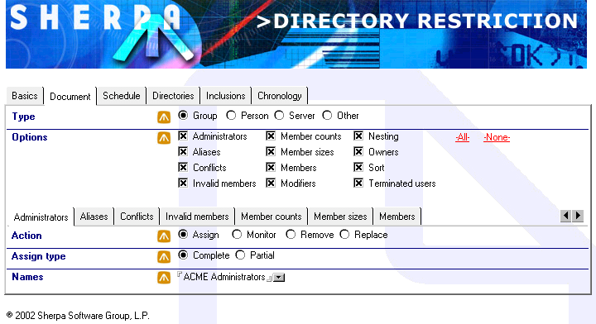

This Document Restriction is managing all possible group options. Within the ‘Administrators’, the group ‘ACME Administrators’ has been assigned as the only value. If Directory Attender encounters any group document that has different values specified for the ‘Administrators’, Directory Attender will replace all other values with ‘ACME Administrators’.

Person document management
Directory Attender can manage person documents using 16 different properties/values:
- Administrators – Assigns, monitors, removes and/or replaces the ‘Administrators’ values within the person documents.
- Aliases – Monitors and/or removes alias names within the person documents. Directory Attender will NOT affect aliases which are valid permutations of the user name.
- Attachments – Monitors and/or removes attachments within the person documents, based upon the creation date of the person document.
- Certificates – Monitors the certificates associated with the person documents, based upon the certificate expiration date. This is done using the documents within the ‘certlog.nsf’ database.
- Conflicts – Monitors and/or removes person document replication/save conflicts.
- Domains – Monitors and/or updates the domain name of the person documents.
- Encryption – Monitors and/or updates the ‘Encrypt incoming mail’ option within the person documents.
- Format preferences – Monitors and/or updates the ‘Format preference for incoming mail’ option within the person documents.
- Forwarding addresses – Monitor and/or removes forwarding addresses within the person documents.
- Internet addresses – Monitor and/or update the internet address for the person documents. Values can be dynamically assigned using ‘keywords’ that reference components of the user name (first initial, first name, middle initial, etc..). Upper/lower case and case insensitivity options are also available.
- Internet passwords – Assign, monitor and/or remove internet passwords within the person documents. Values can be dynamically assigned using ‘keywords’ that reference components of the user name (first initial, first name, middle initial, etc..). Upper/lower case and case insensitivity options are also available.
- Mail systems – Monitors the ‘Mail system’ option within the person documents.
- Middle initials – Monitors the middle initials values within the person documents.
- Modifiers – Monitors the last modifier of the person documents. Administrators can either exclude or include specific names.
- Owners - Assigns, monitors, removes and/or replaces the ‘Owners’ values within the person documents. The person name can also be dynamically maintained, as it is a default value within the directory.
- Short name – Monitors and/or updates the short name values within the person documents. Values can be dynamically assigned using ‘keywords’ that reference components of the user name (first initial, first name, middle initial, etc..). Upper/lower case and case insensitivity options are also available.
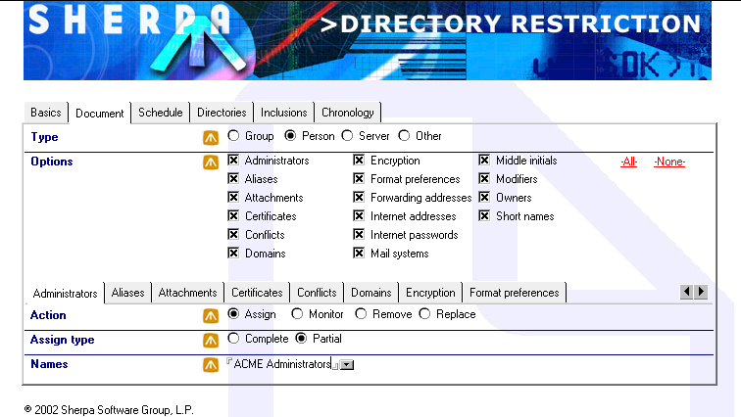

This Document Restriction is managing all possible person options. Within the ‘Administrators’, the group ‘ACME Administrators’ has been assigned as a ‘partial’ value. If Directory Attender encounters any person document that does not have ‘ACME Administrators’ specified for the ‘Administrators’, Directory Attender will assign the value, in addition to leaving all other values intact.

Server document management
Directory Attender can manage server documents using 29 different properties/values:
- Administrators – Assigns, monitors, removes and/or replaces the ‘Administrators’ values within the server documents.
- Attachments – Monitors and/or removes attachments within the server documents, based upon the creation date of the server document.
- Basics – Manages three values within the ‘Basics’ tab/section within the server documents:
- Administrators – Assigns, monitors, removes and/or replaces the ‘Administrators’ values within the server documents. This ‘Administrators’ value is the one used to grant remote console ability.
- Routing tasks – Assign and/or monitor the ‘Routing tasks’ options within the server documents.
- Server build number – Monitor the ‘Server build number’ value within the server documents.
- Certificates – Monitors the certificates associated with the server documents, based upon the certificate expiration date. This is done using the documents within the ‘certlog.nsf’ database.
- Conflicts – Monitors and/or removes server document replication/save conflicts.
- Modifiers – Monitors the last modifier of the server documents. Administrators can either exclude or include specific names.
- Owners - Assigns, monitors, removes and/or replaces the ‘Owners’ values within the server documents.

- Security – Manages values within six tabs/sections of the ‘Security’ tab/section within the server documents:
- Agent restrictions – Manages three values within the ‘Security | Agent restrictions’ tabs/sections:
- Run personal agents - Assigns, monitors, removes and/or replaces the ‘Run personal agents’ values within the server documents.
- Run restricted agents - Assigns, monitors, removes and/or replaces the ‘Run restricted agents’ values within the server documents.
- Run unrestricted agents - Assigns, monitors, removes and/or replaces the ‘Run unrestricted agents’ values within the server documents.
- Java/COM restrictions - Manages two values within the ‘Security | Java/COM restrictions’ tabs/sections:
- Run restricted agents - Assigns, monitors, removes and/or replaces the ‘Run restricted agents’ values within the server documents.
- Run unrestricted agents - Assigns, monitors, removes and/or replaces the ‘Run unrestricted agents’ values within the server documents.
- Passthru use - Manages four values within the ‘Security | Passthru use’ tabs/sections:
- Access this server - Assigns, monitors, removes and/or replaces the ‘Access this server’ values within the server documents.
- Cause calling - Assigns, monitors, removes and/or replaces the ‘Cause calling’ values within the server documents.
- Destinations allowed - Assigns, monitors, removes and/or replaces the ‘Destinations allowed’ values within the server documents.
- Route through - Assigns, monitors, removes and/or replaces the ‘Route through’ values within the server documents.

- Security settings - Manages three values within the ‘Security | Security settings’ tabs/sections:
- Allow anonymous connections – Monitors and/or updates the ‘Allow anonymous connections’ value within the server documents.
- Check passwords – Monitors and/or updates the ‘Check passwords’ value within the server documents.
- Compare public keys – Monitors and/or updates the ‘Compare public keys’ value within the server documents.
- Server access - Manages seven values within the ‘Security | Server access’ tabs/sections:
- Access server - Assigns, monitors, removes and/or replaces the ‘Access server’ values within the server documents.
- Administer from a browser - Assigns, monitors, removes and/or replaces the ‘Administer from a browser’ values within the server documents.
- Allowed to use monitors - Assigns, monitors, removes and/or replaces the ‘Allowed to use monitors’ values within the server documents.
- Create new databases - Assigns, monitors, removes and/or replaces the ‘Create new databases’ values within the server documents.
- Create replica databases - Assigns, monitors, removes and/or replaces the ‘Create replica databases’ values within the server documents.
- Not access server - Assigns, monitors, removes and/or replaces the ‘Not access server’ values within the server documents.
- Not allowed to use monitors - Assigns, monitors, removes and/or replaces the ‘Not allowed to use monitors’ values within the server documents.
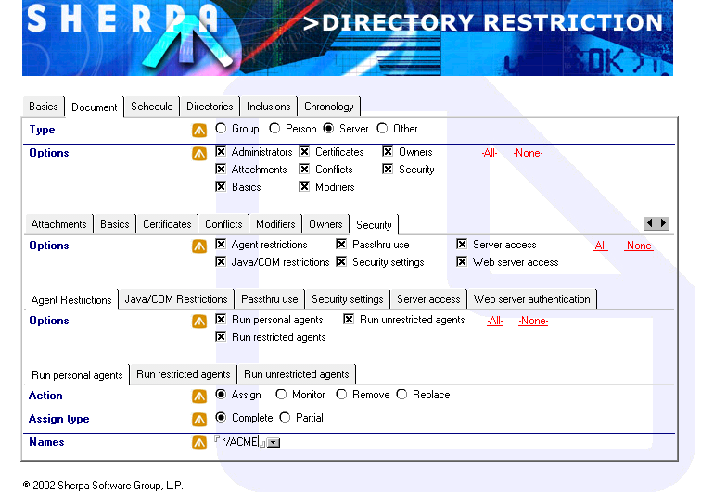

This Document Restriction is managing all possible server options. Within the ‘Security | Agent restrictions | Run personal agents’, the entry ‘*/ACME’ has been assigned as the only value. If Directory Attender encounters any server document that has different values specified for the ‘Run personal agents’, Directory Attender will replace all other values with ‘*/ACME’.

Other document management
Directory Attender can manage all other document types using four different properties/values:
- Administrators – Assigns, monitors, removes and/or replaces the ‘Administrators’ values within the documents.
- Conflicts – Monitors and/or removes document replication/save conflicts.
- Modifiers – Monitors the last modifier of the documents. Administrators can either exclude or include specific names.
- Owners - Assigns, monitors, removes and/or replaces the ‘Owners’ values within the documents.

Content management
Directory Attender can also be used to manage values that span multiple documents. Such is the case for duplicate email addresses, which when existing, can cause one of two problems within your mail routing:
- Prevention of mail delivery – When incoming internet email attempts to resolve an address, the email will be bounced back to the sender, if multiple values for the same email address are found within the directory. This could prevent important business documents from arriving in either a timely fashion, or from arriving at all.
- Improper mail routing – When an employee within your company encounters a duplicate address upon attempting to send an email, the sender will be presented a dialog box that contains all duplicate addresses, and is required to select the appropriate address. Obviously, this could create a two-fold problem; a. The proper recipient did NOT receive the email and b. An improper recipient DID receive the email. The damage caused by this mistake could be very extensive, from a business standpoint.
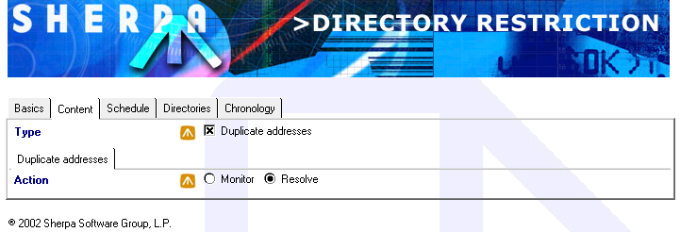

This Content restriction will resolve all possible duplicate email addresses.

ACL management
The Access Control List is the ‘1st security door’ through which someone must pass for your directories. Needless to say, the ACL must NOT have any entries/access levels/roles that could affect the integrity of your data.
Directory Attender offers an ACL Restriction that can be used to ensure that the ACL is maintained properly and consistently. Within the ACL restriction, the administrators specify the valid ACL entries, access levels, rights and roles, and when executing, if Directory Attender encounters any invalid/incorrect entry, Directory Attender will correct the ACL specific to the administrators configuration.
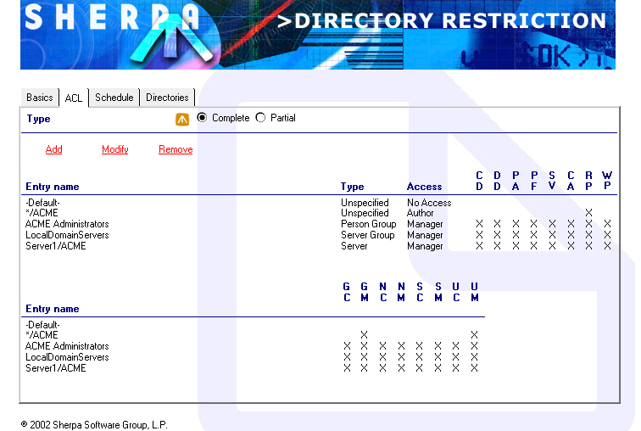

This ACL restriction will assign the specified ACL entries within the directories. All other ACL entries will be removed.

Directory requests
Directory Attender also offers administrators the ability to create reports based upon requests being submitted/processed. Currently, the only type of request available will create a report detailing group membership.
Directory Attender will search through all groups, and report the groups that the specified members are either explicitly or implicitly (via nesting) listed. This can prove very useful from both a security and email standpoint. Once processed, the request will create a child document for each requested entry, detailing the groups and nesting levels (if requested).
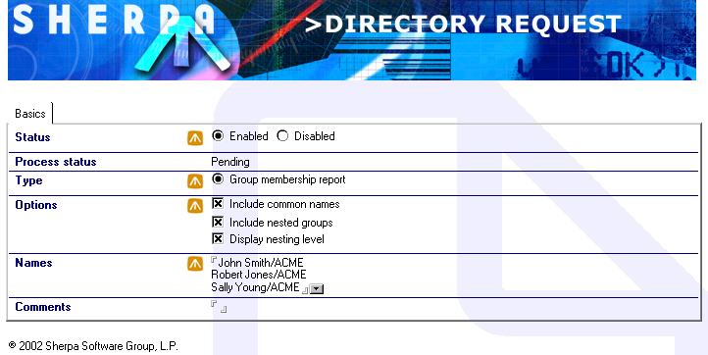

This Group membership report will detail all groups of which the specified names are members, including any matching common names and nested groups (with levels).

Other features
Directory Attender also provides an extensive set of views that can be used to sort and display directory and document information. These views include extensive information regarding the directories themselves (size, # of documents by type, template name, and ACL) or regarding the group, person, server and other documents within the directories.

Summary
Directory Attender exists to ensure that the data integrity of your directories is at their highest possible level. Anything short of perfection is not acceptable, because a possible security or infrastructure problem could manifest itself due to any flaw that exists. Directory Attender will be an invaluable tool for your directory management.
We welcome requests for new functionality within Directory Attender. The more features that are implemented per your request, the more useful and important Directory Attender will become.

Contact information
If you need additional information regarding Directory Attender, please contact the following:
Sales contact

Theresa Zajacs
800-255-5155 x208
412-206-0005 x208
412-206-0018 (FAX)
tzajacs@sherpasoftware.com

Technical contact

Jeff Tujetsch
800-255-5155 x206
412-206-0005 x206
412-206-0018 (FAX)
jtujetsch@sherpasoftware.com

